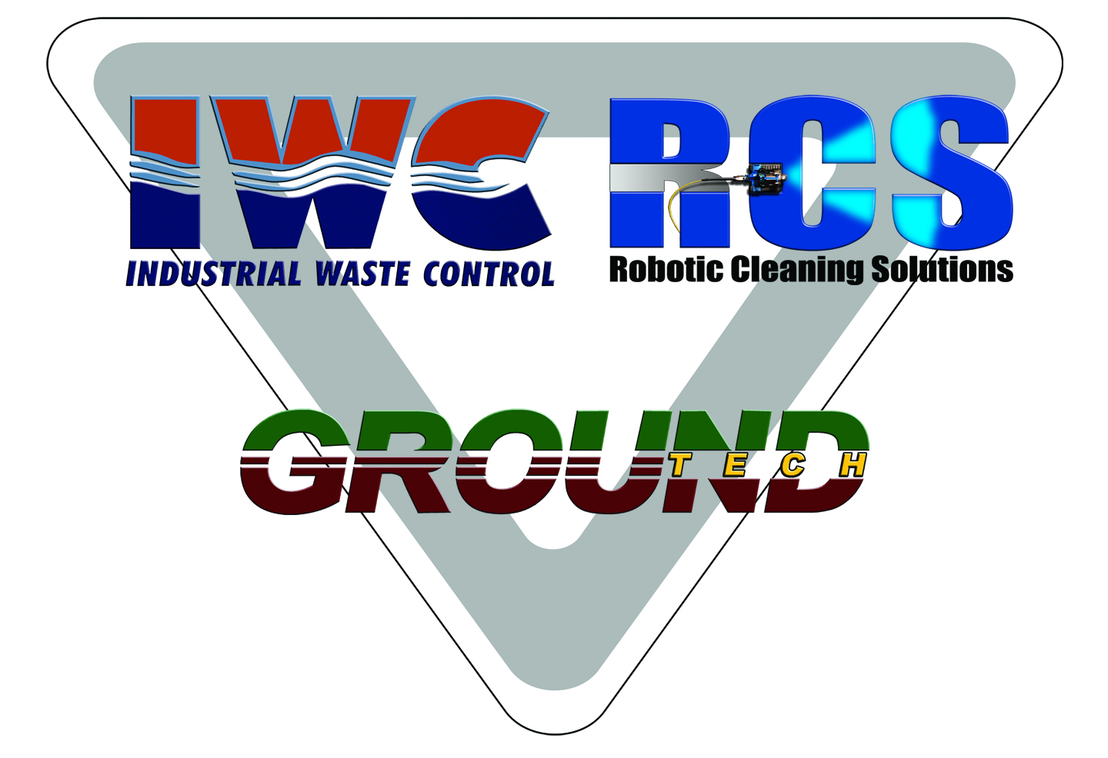
Krissy,
Matt Kleese has classified this material as oil field waste.
Republic Waste (Carbon Limestone Division) at 8100 South State Line Road, Lowellville, Ohio. Has approved your waste that is under 6.99 pCi/gm. Every box has to be tested for Radium 226/228. Analytical must be supplied to Republic Waste to receive a manifest.
Liquid that can be vacuumed off the vacuum boxes will be taken to KDA’s Natale well in Warren, Ohio.
Material that is Radiated greater than 6.99 pCi/gm will go to Austin Masters Facility in Martins Ferry, Ohio were it will be solidified and loaded into a gondola then trained to Energy Solutions in Utah.

